EXPERIMENT 1b
IMPLEMENTATION OF CRISP-DM USING TRANSACTION DATASET
Aim
To implement the CRISP-DM (Cross Industry Standard Process for Data Mining) methodology by analyzing a transaction dataset using Python and Pandas.
Algorithm
Step 1: Business Understanding
Define the objective of analyzing the transaction dataset.
Step 2: Data Understanding
Import the dataset and examine its structure, data types, and summary statistics.
Step 3: Data Preparation
Check for missing values, duplicate records, and convert the timestamp column into the appropriate datetime format.
Step 4: Modeling
Perform basic data analysis such as calculating transaction totals, averages, and frequency counts.
Step 5: Evaluation
Evaluate the analysis by interpreting transaction statistics and transaction status distribution.
Step 6: Deployment
Present the analyzed results and insights for reporting and decision-making.
Program 1: Business Understanding

Objective:

Analyze the transaction dataset to understand transaction patterns,

transaction amounts, and success/failure status.

Program 2: Data Understanding
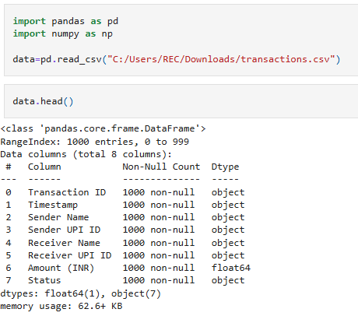
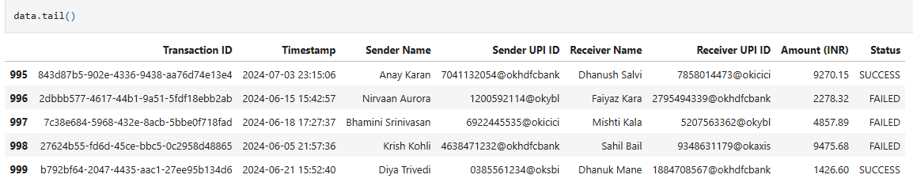
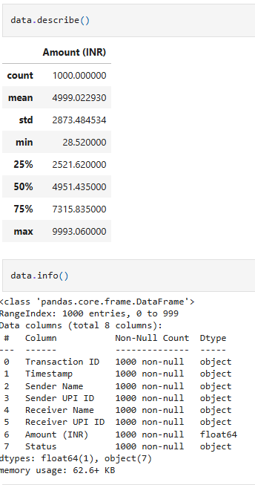

Program 3: Data Preparation
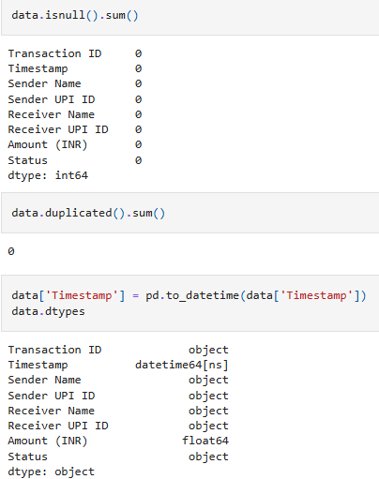

Program 4: Modeling
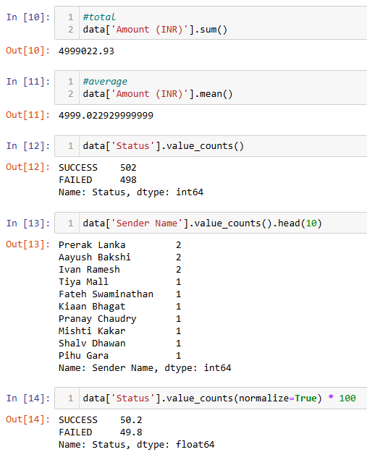
Program 5: Evaluation
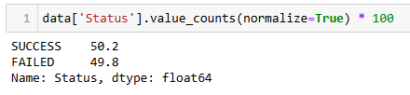

Program 6: Deployment
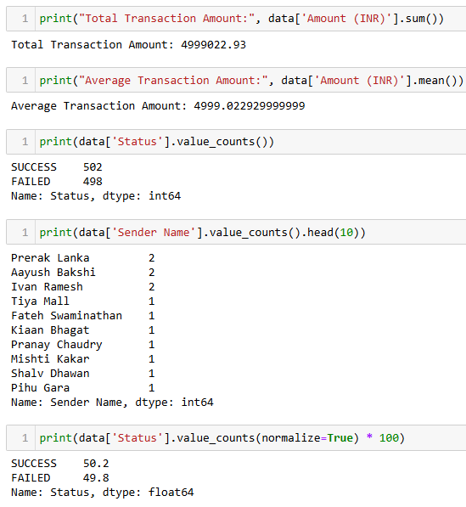

Result
Thus, the CRISP-DM methodology was successfully implemented on the transaction dataset. The data was imported, understood, prepared, analyzed, evaluated, and the results were presented successfully using Python and Pandas.

